Project Design Phase-II Technology Stack (Architecture & Stack)

|  |  |
| --- | --- |
| Date | 16 October 2022 |
| Team ID | PNT2022TMID14116 |
| Project Name | Smart Fashion Recommender Application |
| Maximum Marks | 4 Marks |

Technical Architecture:

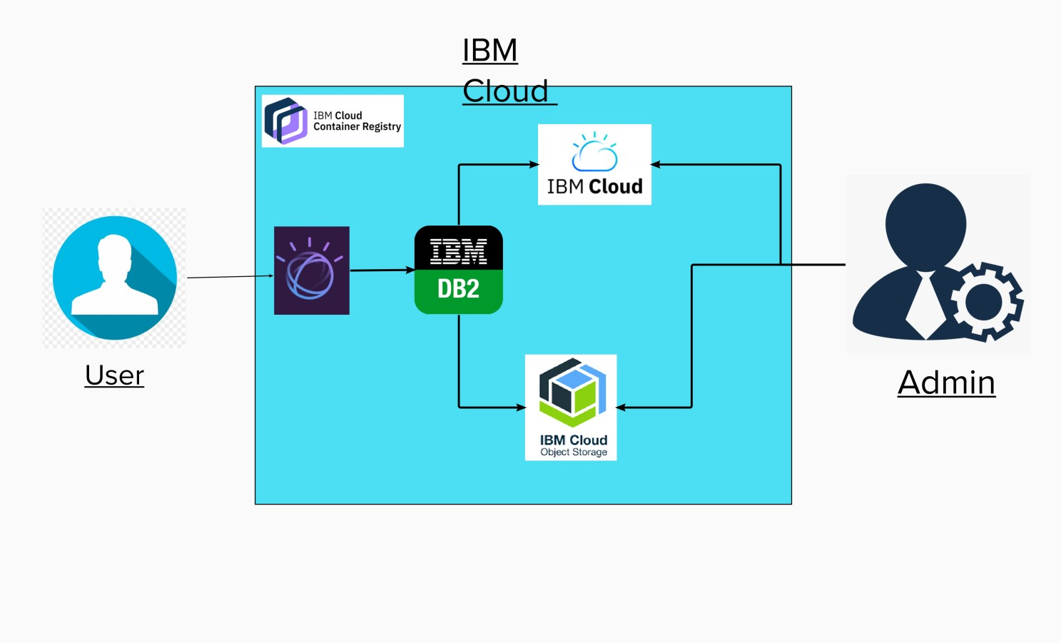

Table-1 : Components & Technologies:

|  |  |  |  |
| --- | --- | --- | --- |
| **S.No** | **Component** | **Description** | **Technology** |
| 1. | User Interface | How user interacts with application e.g. Web UI, Mobile App, Chatbot etc. | HTML, CSS, JavaScript |
| 2. | Application Logic-1 | Logic for a process in the application | Python |
| 3. | Application Logic-2 | Logic for a process in the application | IBM Watson STT service |
| 4. | Application Logic-3 | Logic for a process in the application | IBM Watson Assistant |
| 5. | Database | Data Type, Configurations etc. | MySQL |
| 6. | Cloud Database | Database Service on Cloud | IBM DB2 |
| 7. | File Storage | File storage requirements | IBM Block Storage |
| 8. | Infrastructure (Server / Cloud) | Application Deployment on Cloud  Cloud Server Configuration : Db2 /python | Kubernetes, |

Table-2: Application Characteristics:

|  |  |  |  |
| --- | --- | --- | --- |
| **S.No** | **Characteristics** | **Description** | **Technology** |
| 1. | Open-Source Frameworks | Flask | Python |
| 2. | encryption hashing and salting | Encryption hashing and salting | Encryptions |
| 3. | Scalable Architecture | Getting resources to different parts of the system that need it | Microservices Architecture |
| 4. | Availability | The Application available 24/7 | IBM Cloud |
| 5. | Performance | 1000 request per day | IBM Watson |